Tessellating Tess

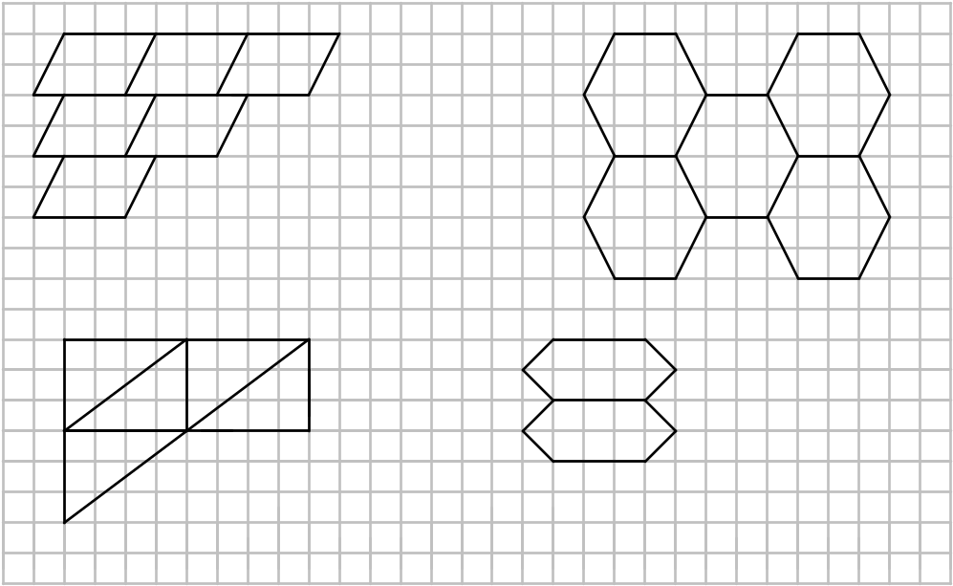1. Tess is designing tiling patterns for her new kitchen. She has come up with the four tiles shown below. Copy each of these diagrams onto squared paper. Repeat the shape several times to show how it tessellates. You must repeat the shape at least six times.

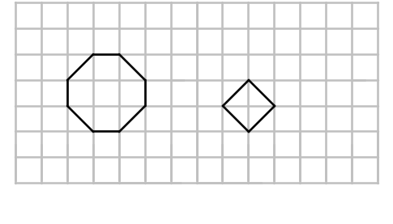2. Tess thinks back to when she was at school. She can remember making a tiling design using an octagon and a square. Use the two shapes in the grid below to show how this can be done.
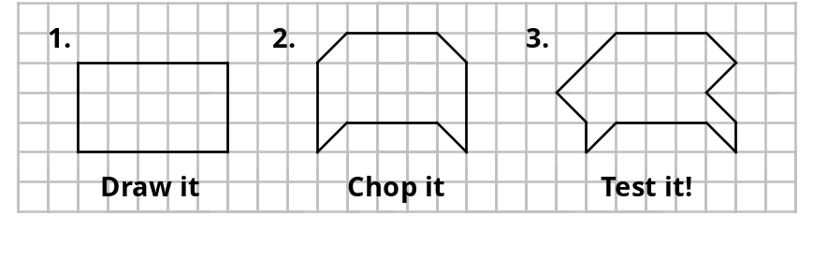3. Draw a rectangle on squared paper. Cut a section out from the bottom and add it on to the top. Now cut a section out of the right hand side and add it to the left hand side.. Does your new shape tessellate?

4. Any quadrilateral will tessellate. True or False? Explain your answer using diagrams to help.

